1. What are the benefits of using CSS?

* CSS allows you to separate the content of a web page from its presentation. By defining styles in a separate CSS file, you can change the visual appearance of multiple pages by simply modifying a single file.
* CSS enables you to create consistent styling across multiple pages of a website or an entire application. With CSS, you can define styles for various elements, such as headings, paragraphs, links, and more, and apply them consistently throughout your project.
* CSS provides a wide range of styling options and properties that give you precise control over the presentation of your content. You can define colors, fonts, margins, padding, layout, and more, allowing you to tailor the appearance of your web pages according to your specific needs and design preferences.

1. What are the disadvantages of CSS?

* CSS can be complex, especially when dealing with advanced layout techniques and cross-browser compatibility.
* Different web browsers interpret CSS code differently, leading to inconsistencies in rendering and layout.
* While CSS provides a wide range of layout options, it still has limitations when it comes to complex and dynamic layouts.
* CSS lacks built-in support for variables and dynamic features. This means that you cannot easily declare and reuse values throughout your stylesheets, making it more cumbersome to maintain consistency and make global changes.

1. What is the difference between CSS2 and CSS3?

* Unlike CSS2, which was comprised of a single document, CSS3 has its specifications divided into many individual modules, which makes CSS3 a whole lot easier to handle. With CSS3, the designers can now use special fonts, like those available in Google Fonts and Typecast.

1. Name a few CSS style components

* font-size.
* width.
* background-color.
* color.
* border.

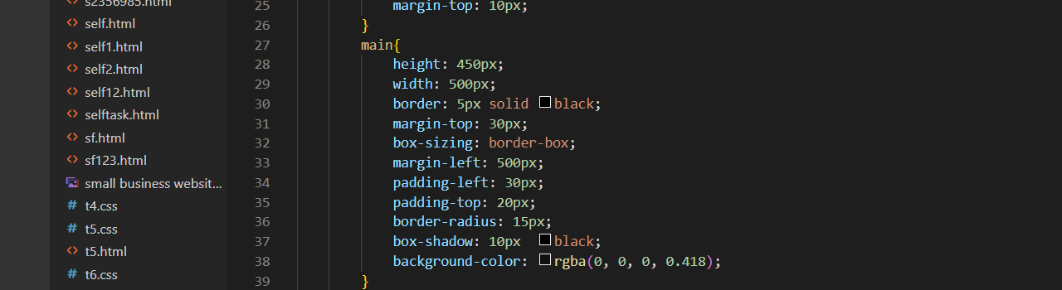

1. What do you understand by CSS opacity?

* Opacity is the degree to which content behind an element is hidden, and is the opposite of transparency

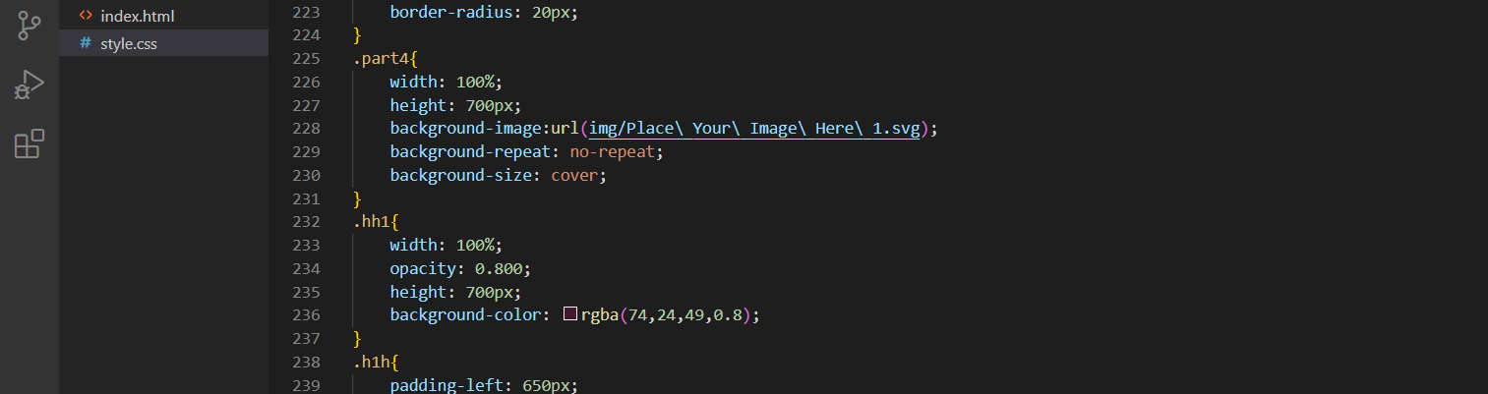

1. How can the background color of an element be changed?

* To add background color in HTML, use the CSS background-color property.

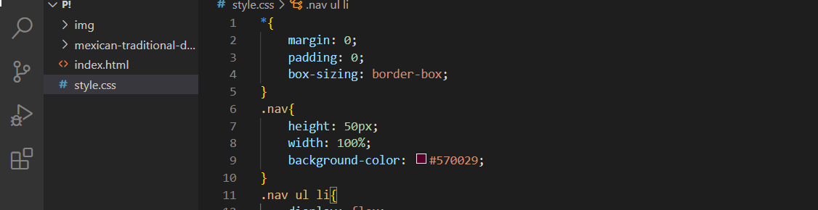

1. How can image repetition of the backup be controlled?

* To control the repetition of an image in the background, use the background-repeat property.

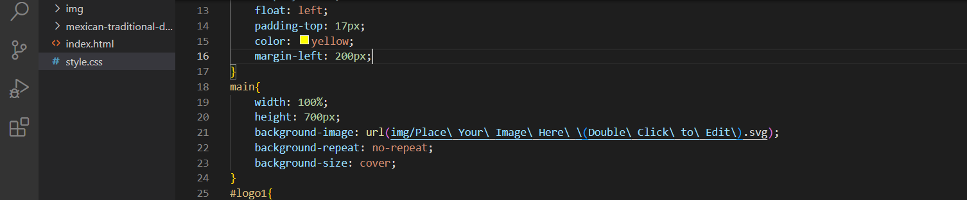

1. What is the use of the background-position property?

* The background-position property sets the starting position of a background image

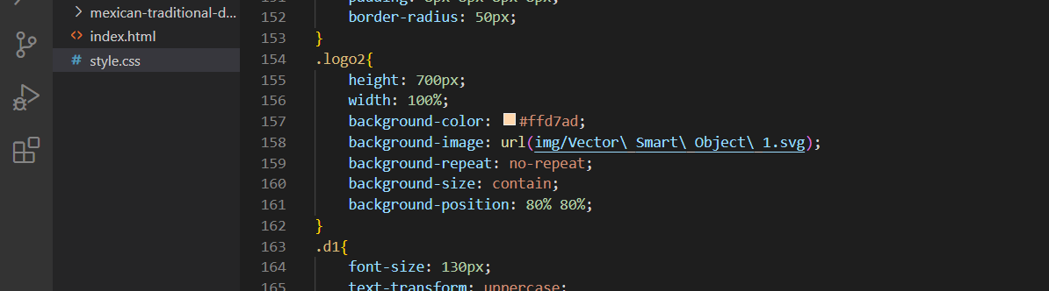

1. Which property controls the image scroll in the background?

* The background-attachment property sets whether a background image scrolls with the rest of the page, or is fixed.

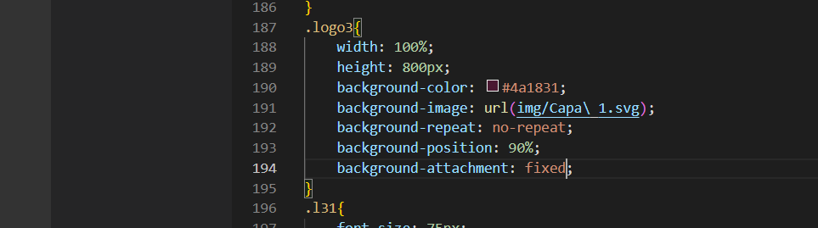

1. Why should background and color be used as separate properties?

* It enhances the legibility of style sheets.



1. How to center block elements using CSS1?

* To centrally align the block elements, we can simply make use of the <center> tag.

1. How to maintain the CSS specifications?

* Version Control: Use a version control system like Git to manage your CSS files. This allows you to track changes, collaborate with others, and easily revert to previous versions if needed.
* Modular Approach: Break down your CSS into modular components, such as separate files for typography, layout, components, and themes. This makes it easier to manage and update specific parts of your stylesheets.
* Documentation: Document your CSS specifications, including the purpose of each style, any guidelines or restrictions, and how to use the CSS classes effectively. This documentation serves as a reference for developers and helps maintain consistency across your project.

1. What are the ways to integrate CSS as a web page

* To style a single HTML element on the page, use Inline CSS in a style attribute. By adding CSS to the head section of our HTML document, we can embed an internal stylesheet. We can also connect to an external stylesheet that separates our CSS from our HTML

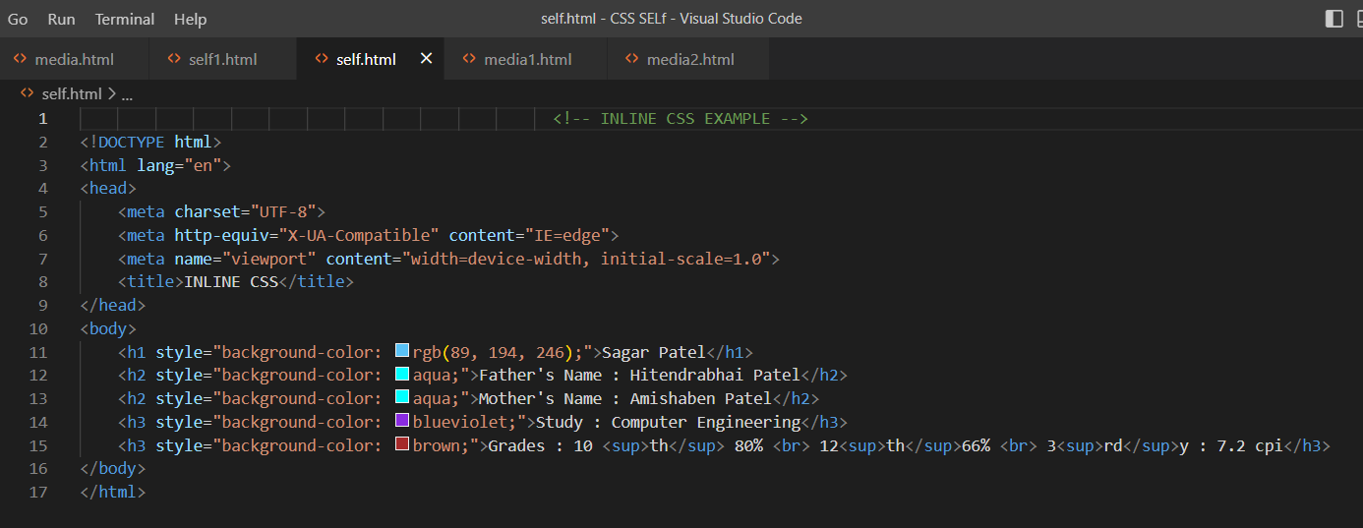

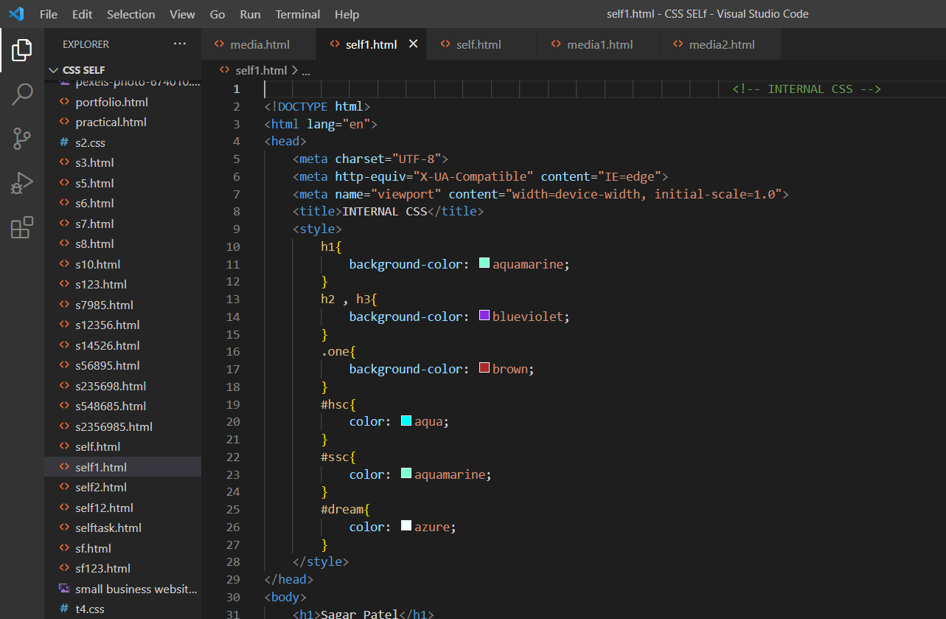

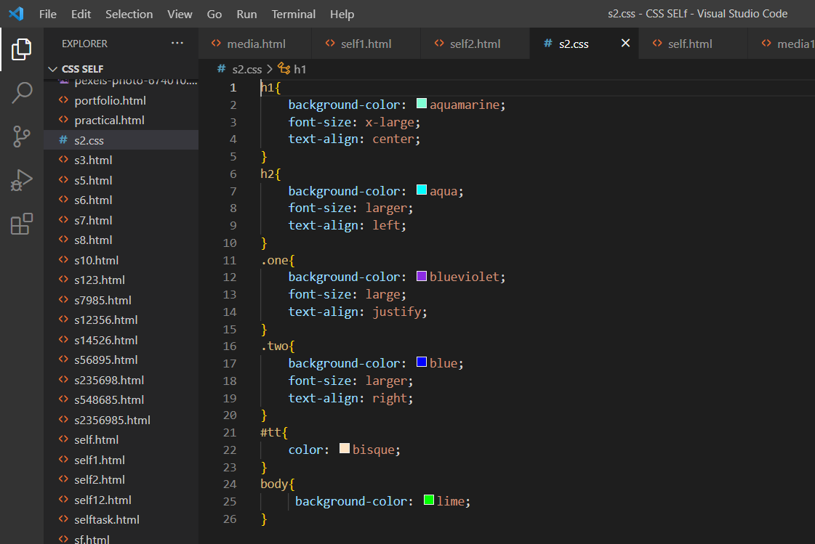

1. What is embedded style sheets?

* An embedded style sheet is declared within the <head> element of an XHTML document.



1. What are the external style sheets?

* An external style sheet is a separate CSS file that can be accessed by creating a link within the head section of the webpage.



1. What are the advantages and disadvantages of using external style sheets?

* Advantages :-
* With the help of External Style Sheets, the styles of numerous documents can be organized from one single file.
* In External Style Sheets, Classes can be made for use on numerous HTML element types in many forms of the site.
* In complex contexts, Methods like selector and grouping can be implemented to apply styles
* Disadvantages :-
* An extra download is essential to import style information for each file.
* The execution of the file may be deferred till the external style sheet is loaded.
* While implementing style sheets, we need to test Web pages with multiple browsers in order to check compatibility issues.

1. What is the meaning of the CSS selector?

* A CSS selector is the first part of a CSS Rule. It is a pattern of elements and other terms that tell the browser which HTML elements should be selected to have the CSS property values inside the rule applied to them



1. What are the media types allowed by CSS?

* continuous or paged.
* visual, audio, speech, or tactile.
* grid (for character grid devices), or bitmap

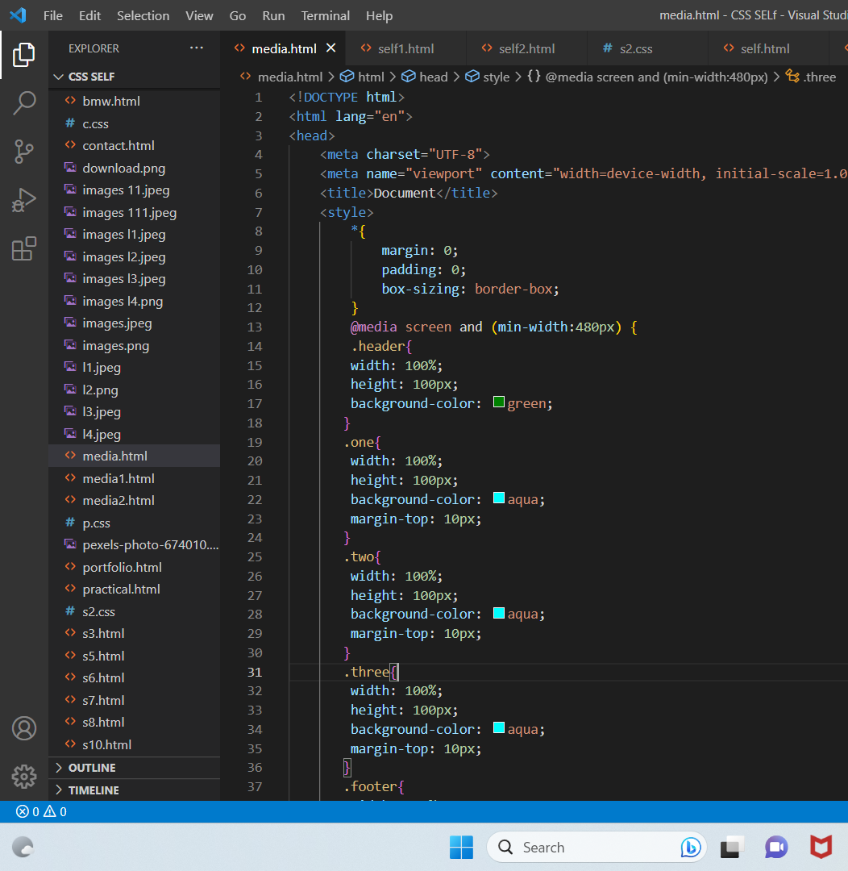

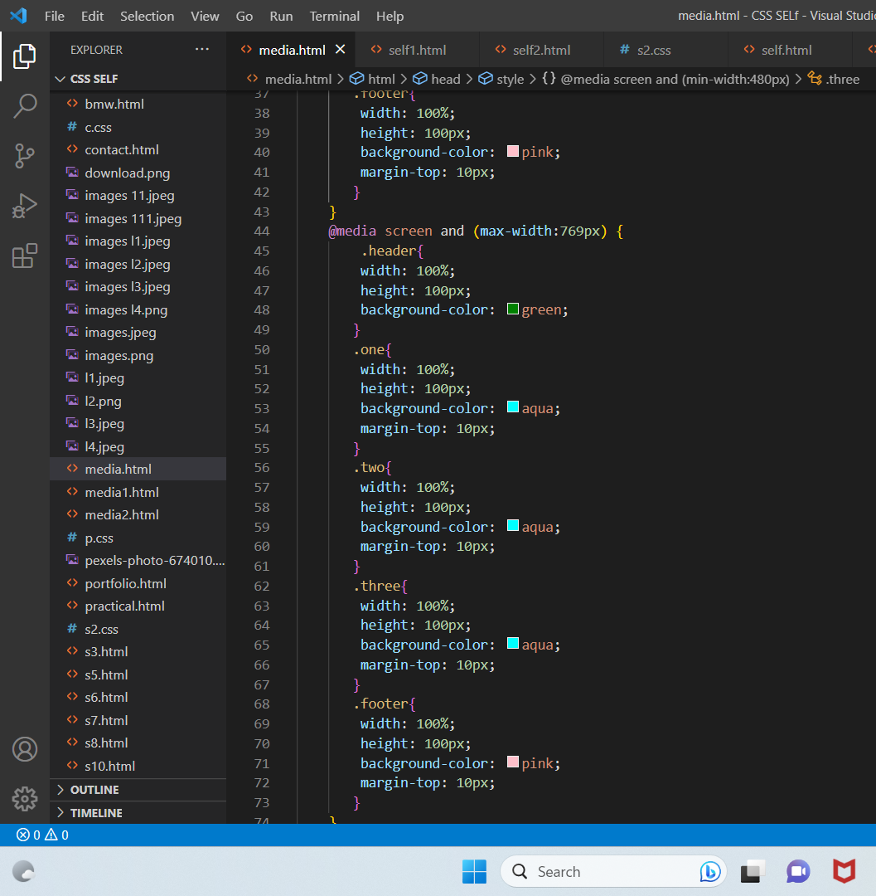

1. What is the rule set?

* A table of instructions used by a controlled interface to determine what data is allowable and how the data is handled between interconnected systems.

1. Create Layouts

